**Chapter 4**

**Features of Marketing Research**

The characteristics or features of marketing research are as follows:

**1.Wide and comprehensive scope** - Marketing research has a very wide scope. It includes product research, packaging research, pricing research, market research, sales research, etc. It is used to solve marketing problems and to take marketing decisions. It is used to make marketing policies. It is also used to introduce new products in the market and to identify new markets. Marketing research is used to select channels of distribution, in advertising strategy, for sales promotion measures, etc.

**2.Systematic and scientific** - Marketing research is conducted in a step-by-step manner. It is conducted in an orderly fashion. Therefore, it is systematic. Marketing research uses scientific methods. Thus, it is also scientific.

**3.Science and art** : A Science collects knowledge (data) while an Art uses this knowledge for solving problems. Marketing research first collects data. It then uses this data for solving marketing problems. Therefore, it is both, a Science and an Art.

**4.Collects and analyzes data** - Marketing research gathers data accurately and objectively. It first collects reliable data and then analyses it systematically and critically.

**5.Continuous and dynamic process** - The company faces marketing problems throughout the year. So, Marketing research is conducted continuously. It continuously collects up-to-date data for solving the marketing problems. Large companies have their own marketing research departments. They conduct Marketing research continuously throughout the year. Therefore, Marketing research is a continuous process. It is a dynamic process because it goes on .changing. It does not remain static (the same).

**6.Tool for decision-making** - The marketing manager has to take many decisions. For this, he requires a lot of data. Marketing research provides correct and up-to-date data to the marketing manager. This helps him to take quick and correct decisions. Therefore, Marketing research is an important tool for decision-making.

**7.Benefits company and consumers** - Marketing research is useful to the company in many ways. It increases the sales and profits of the company. It helps the company to fight competition and boost its goodwill in the market. It reduces the marketing risks. In short, Marketing research brings success to the company. It also brings the company closer to the consumers. It gives convenience and satisfaction to the consumers.

**8.Similar to military intelligence** - Marketing research is a commercial intelligence-gathering activity. It works similar to military intelligence. Marketing intelligence first makes a systematic study and only then takes a business action. Marketing research collects reliable data about the consumers, the competitors, the market, etc. This data is then organised and used for planning, decision-making and problem solving. This data is also further used for introducing new products and services in the market.

**9.Applied research** - Applied research is used for solving problems. Marketing research is used for solving marketing problems. Therefore, we can say that, Marketing research is also an applied research. It has a practical value because it is used for solving present and future problems.

**10.Reduces gap between producers and consumers** - Marketing research informs producers about the needs and wants of the consumers. The producers produce goods according to the needs and demands of the consumers. This brings satisfaction to the consumers and in return producers make good profits. So, Marketing research reduces the gap between the producers and the consumers.

**11.**collecting data, viz., Survey Method, Experiment Method and Observation Method. All three methods are scientific. The researcher has to use a suitable method for collecting a reliable data.

**12.Has few limitations** - Marketing research has few limitations too. It is not an exact science. So, it does not give accurate results. It provides suggestions and not solutions. It is also a costly and time-consuming process.

**13.Accurate data collection and critical analysis** - Marketing research gives much importance to accurate data collection and its critical analysis. Thus, in a Marketing research, the data must be first collected accurately.

**Chapter 5**  
 Needs of marketing research

[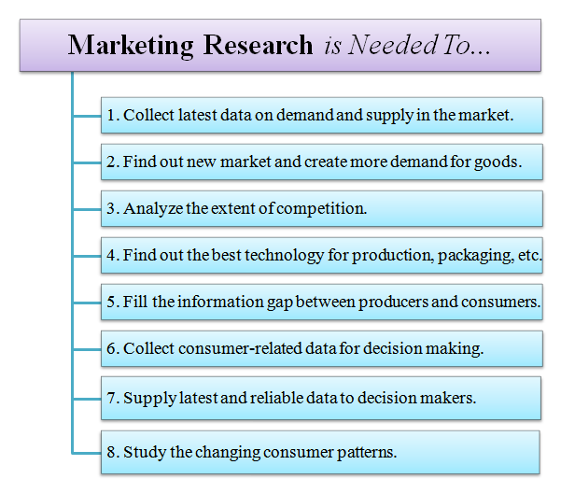](http://lh6.googleusercontent.com/-bQZ7ZBaTkqE/UPfW-M8CXFI/AAAAAAAAGnY/-Bu_KC9BCr0/s640/Explain-the-Need-For-Marketing-Research.png)

Now let’s discuss above points highlighting the need for marketing research.

1. **Expansion of marke**
2. Due to development in means of transport and communication, market has expanded from local to global level. The structure of market has also changed. There is a need for marketing research to collect latest data on demand and supply in the market, extent of competition, etc. This data is used to make production & marketing policies and strategies.

**2. Large-scale production**

Automation has helped to produce goods of standard quality on a large scale. There is a need for marketing research to find out new market or to create more demands for these goods.

**3. Increased competition**

Competition is unavoidable in an open and globalized economy. It has endangered the survival and growth prospects of many firms. There is a need for marketing research to analyze the extent of competition. It also provides steps to fight competition.

**4. Growth of science and technology** Increasing use of science and technology has helped to reduce the cost of production and improve the quality of production. There is a need for marketing research to find out the best technology for production, packaging, data, storing, etc.

**5. Information gap**

Due to centralized production and decentralized consumption, there is an information gap between producer and consumer. This information gap can be filled by marketing research. Hence it is needed.

**6. Role of consumerism**

Today, consumers are organised. They are aware of their rights and duties. They are now more selective. They will not accept an inferior quality product.

Consumer research is needed to collect demographic and psychological data about consumers. This data is used for decision making. There is a need for marketing research as consumer research is a part of it.

**7. Information needs**

There is a need for marketing research to supply latest and reliable data to the decision makers. This will improve the quality and success rate of decisions.

**8. Consumer pattern**

Consumers are now more quality conscious. They are willing to pay a higher price but for a better quality. There is a need for marketing research to study the likes and dislikes, preferences and interest of rural and urban consumers

**Chapter 6**

**Importance of Marketing Research (MR**)

[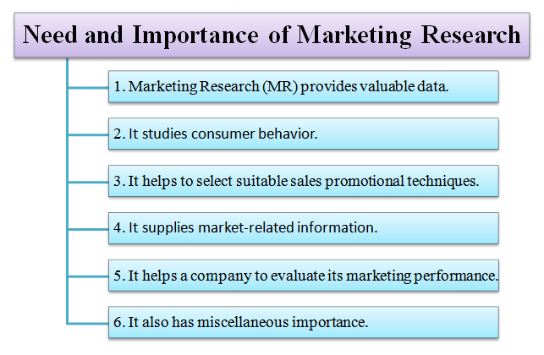](http://lh4.googleusercontent.com/-J_v_ALzfWFY/UPb2cEtR86I/AAAAAAAAGmM/zHD3tCXUmIc/s720/Importance-of-Marketing-Research.png)

. 1. Provides valuable data

Marketing research provides valuable data to the decision makers. It provides data about demand, supply, consumer behavior, competition, etc. This data is used for [decision making](http://kalyan-city.blogspot.in/2011/08/what-is-decision-making-meaning.html). This data improves the quality of decisions. It makes the decision very successful.

2. Studies consumer behaviour Marketing research provides data about consumer behavior. It provides data about age, incomes, likes, dislikes, etc. of the consumers. It also finds out the opinions of the consumers about a company’s product. This data is used to make production and marketing policies.

3. Selects promotional techniques

Marketing research helps the company to select suitable sales promotion techniques. It helps to select marketing techniques. It helps to select proper media for advertising. It helps to solve the problems of after-sales service. It also helps to prepare the budget for advertising and sales promotion.

4. Supplies marketing information

Marketing research supplies data about the market situation.

This market-related data is used to find out:

The present and future demand and supply position.

The level of competition and steps taken to control it.

Market opportunities.

The cause of fall in sales level.

5. Evaluates marketing performance Marketing research helps the company to evaluate its marketing performance and to take steps to improve it.

Marketing research is used to find out the effect of price, package, brand name, etc. on sales. It is used to find consumers’ reaction towards the company’s product. It is used to evaluate the inventory and pricing policies. It is also used to evaluate the effectiveness of advertising, sales promotion techniques, channels of distribution, etc.

6. Miscellaneous needs and importance

Miscellaneous needs and importance of marketing research are as follows:

Marketing research improves the efficiency of the marketing department. This creates goodwill and good reputation.

It helps the marketing manager to take the rational and effective decisions.

It helps to choose suitable staff for doing research.

It is used to make growth and expansions programs.

It benefits all i.e. it benefits the company, distributor, advertising agency, consumer, government and the entire society.

So, marketing research is very helpful to everyone. But it is most useful to a manufacturer because it helps to answer the basic questions, i.e. what, where, when, who, whom and how to sell?

**Chapter 7**

**Limitations of Marketing Research**

[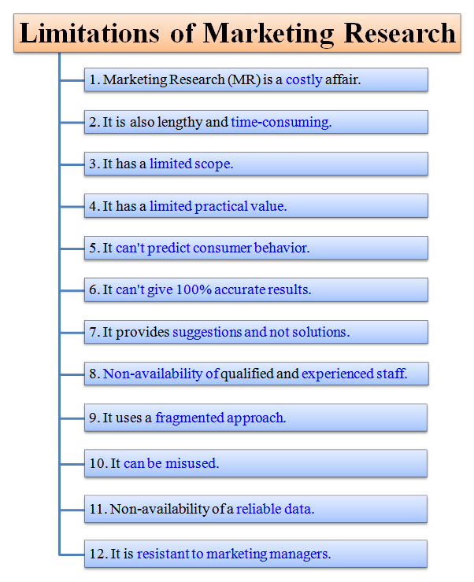](http://lh3.googleusercontent.com/-VJZNmdSONuM/UPbY_FW8pNI/AAAAAAAAGlc/jEnZYw_qSSU/s800/Limitations-of-Marketing-Research.png)

The limitations or disadvantages of marketing research are as follows:

1.Costly : Marketing research is a costly affair. It needs a lot of [money](http://kalyan-city.blogspot.com/2011/07/what-is-money-meaning-definition.html) to conduct various market research activities. Huge funds are required to pay salaries, prepare questionnaires, conduct surveys, prepare reports, etc. It is not a viable choice for small businesses. It is suitable only to large companies who can afford its cost.

2.Time consuming : Marketing research is a lengthy and time-consuming process. This process involves many important steps. All these steps are crucial and not even a single step can be neglected or avoided. In other words, there are no short-cuts in MR. Generally, it takes at least three to six months to solve a marketing problem. Therefore, it cannot be used in urgent or emergency situations.

3.Limited scope : Marketing research solves many business-related problems. However, it cannot solve all business problems. It cannot solve problems related to consumer behavior, income and expenditure relationship, etc. Thus, its scope is limited.

4.Limited practical value : Marketing research is only an academic exercise. It is mainly based on a hypothetical approach. It gives theoretical solutions. It does not give realistic solutions to real-life problems. Its solutions look good on paper but are harder to implement in a real sense. Thus, it has a limited practical value.

5. predict consumer behavior : Marketing research collects data about consumer behavior. However, this data is not accurate because consumer behavior cannot be predicted. It keeps on changing according to the time and moods of the consumers. Consumer behavior is also very complex. It is influenced by social, religious, family, economic and other factors. It is very difficult to study these factors.

6.No accurate results : Marketing research is not a physical science like physics, chemistry, biology, etc. It is a social science. It studies consumer behavior and marketing environment. These factors are very unpredictable. Therefore, it does not give accurate results. It gives results, but it cannot give 100% correct results.

7.Provides suggestions and not solutions : Marketing research provides data to the marketing manager. It guides and advises him. It also helps him to solve the marketing problems. However, it does not solve the marketing problem. The marketing manager solves the marketing problems. So, MR only provides suggestions. It does not provide solutions.

8.Non-availability of technical staff : Marketing research is done by researchers. The researchers must be highly qualified and experienced. They must also be hard-working, patient and honest. However, in India, it is very difficult to find good researchers. Generally, it is done by non-experienced and non-technical people. Therefore, MR becomes a costly, time-consuming and unreliable affair. So, its quality is also affected due to non-availability of technical staff.

9.Fragmented approach : Marketing research studies a problem only from a particular angle. It does not take an overall view into consideration. There are many causes for a marketing problem. It does not study all causes. It only studies one or two causes. For example, if there is a problem of falling sales. There are many causes for falling sales; like, poor quality, high-price, competition, recession, consumer resistance, etc. It will only study two causes viz; low-quality and high price. It will not study other causes. So, it is not a 10

10.Can be misused : Sometimes, marketing research is misused by the company. It is used to delay decisions. It is used to support the views of a particular individual. It is also used to grab power (managerial) in the company.

11.Non-availability of reliable data : The quality of the marketing research report depends on the quality of the collected data. If the data is complete, up-to-date and reliable, then the MR report will also be reliable. However, in India, it is very difficult to get full, latest and trustworthy data. So, non-availability of a reliable data is also its limitation.

12.Resistance of marketing managers : The marketing managers do not use the suggestions given in the marketing research report. Primarily, they feel that these suggestions are not practical. Secondly, they also feel that their importance will become less if they use these suggestions. There is a conflict between the marketing managers and the researchers.

**Chapter 8**

# 7 Stages or Steps Involved in Marketing Research Process

Some of the major steps involved in marketing research process are as follows: 1. Identification and Defining the Problem 2. Statement of Research Objectives 3. Planning the Research Design or Designing the Research Study 4. Planning the Sample 5. Data Collection 6. Data Processing and Analysis 7. Formulating Conclusion, Preparing and Presenting the Report.

Marketing research exercise may take many forms but systematic enquiry is a feature common to all such forms. Being a systematic enquiry, it requires a careful planning of the orderly investigation process.

Though it is not necessary that all research processes would invariably follow a given sequence, yet marketing research often follows a generalised pattern which can be broken down and studied as sequential stages.

**The various stages or steps in the marketing research process are discussed below:**

#### 1. Identification and Defining the Problem:

The market research process begins with the identification “of a problem faced by the company. The clear-cut statement of problem may not be possible at the very outset of research process because often only the symptoms of the problems are apparent at that stage. Then, after some explanatory research, clear definition of the problem is of crucial importance in marketing research because such research is a costly process involving time, energy and money.

Clear definition of the problem helps the researcher in all subsequent research efforts including setting of proper research objectives, the determination of the techniques to be used, and the extent of information to be collected.

It may be noted that the methods of explanatory research popularly in use are—survey of secondary data, experience survey, or pilot studies, i.e., studies of a small initial sample. All this is also known as ‘preliminary investigation’.

#### 2. Statement of Research Objectives:

After identifying and defining the problem with or without explanatory research, the researcher must take a formal statement of research objectives. Such objectives may be stated in qualitative or quantitative terms and expressed as research questions, statement or hypothesis. For example, the research objective, “To find out the extent to which sales promotion schemes affected the sales volume” is a research objective expressed as a statement.

On the other hand, a hypothesis is a statement that can be refuted or supported by empirical finding. The same research objective could be stated as, “To test the proposition that sales are positively affected by the sales promotion schemes undertaken this winter.”

Example of another hypothesis may be: “The new packaging pattern has resulted in increase in sales and profits.” Once the objectives or the hypotheses are developed, the researcher is ready to choose the research design.

#### 3. Planning the Research Design or Designing the Research Study:

After defining the research problem and deciding the objectives, the research design must be developed. A research design is a master plan specifying the procedure for collecting and analysing the needed information. It represents a framework for the research plan of action.

The objectives of the study are included in the research design to ensure that data collected are relevant to the objectives. At this stage, the researcher should also determine the type of sources of information needed, the data collection method (e.g., survey or interview), the sampling, methodology, and the timing and possible costs of research.

#### 4. Planning the Sample:

Sampling involves procedures that use a small number of items or parts of the ‘population’ (total items) to make conclusion regarding the ‘population’. Important questions in this regard are— who is to be sampled as a rightly representative lot? Which is the target ‘population’? What should be the sample size—how large or how small? How to select the various units to make up the sample?

#### 5. Data Collection:

The collection of data relates to the gathering of facts to be used in solving the problem. Hence, methods of market research are essentially methods of data collection. Data can be secondary, i.e., collected from concerned reports, magazines and other periodicals, especially written articles, government publications, company publications, books, etc.

Data can be primary, i.e., collected from the original base through empirical research by means of various tools.

**There can be broadly two types of sources**

(i) Internal sources—existing within the firm itself, such as accounting data, salesmen’s reports, etc.

(ii) External sources—outside the firm.

#### 6. Data Processing and Analysis:

Once data have been collected, these have to be converted into a format that will suggest answers to the initially identified and defined problem. Data processing begins with the editing of data and its coding. Editing involves inspecting the data-collection forms for omission, legibility, and consistency in classification. Before tabulation, responses need to be classified into meaningful categories.

The rules for categorizing, recording and transferring the data to ‘data storage media’ are called codes. This coding process facilitates the manual or computer tabulation. If computer analysis is being used, the data can be key punched and verified.

Analysis of data represents the application of logic to the understanding of data collected about the subject. In its simplest form analysis may involve determination of consistent patterns and summarising of appropriate details.

The appropriate analytical techniques chosen would depend upon informational requirements of the problem, characteristics of the research designs and the nature of the data gathered. The statistical analysis may range from simple immediate analysis to very complex multivariate analysis.

#### 7. Formulating Conclusion, Preparing and Presenting the Report:

The final stage in the marketing research process is that of interpreting the information and drawing conclusion for use in managerial decision. The research report should clearly and effectively communicate the research findings and need not include complicated statement about the technical aspect of the study and research methods.

Often the management is not interested in details of research design and statistical analysis, but instead, in the concrete findings of the research. If need be, the researcher may bring out his appropriate recommendations or suggestions in the matter. Researchers must make the presentation technically accurate, understandable and useful.